

Flexible Solutions International Inc. AMEX:FSI
FQ3 2019 Earnings Call Transcripts
Friday, November 15, 2019 4:00 PM GMT
S&P Global Market Intelligence Estimates
 | -FQ3 2019- |  |  | -FQ4 2019- | -FY 2019- | -FY 2020-
 | CONSENSUS | ACTUAL | SURPRISE | CONSENSUS | CONSENSUS | CONSENSUS
EPS (GAAP) | 0.05 | 0.03 | (40.00 %) | 0.08 | 0.21 | 0.33
Revenue (mm) | 7.90 | 7.40 | (6.33 %) | 8.42 | 31.56 | 35.40
Currency: USD
Consensus as of Aug-15-2019 8:45 PM GMT

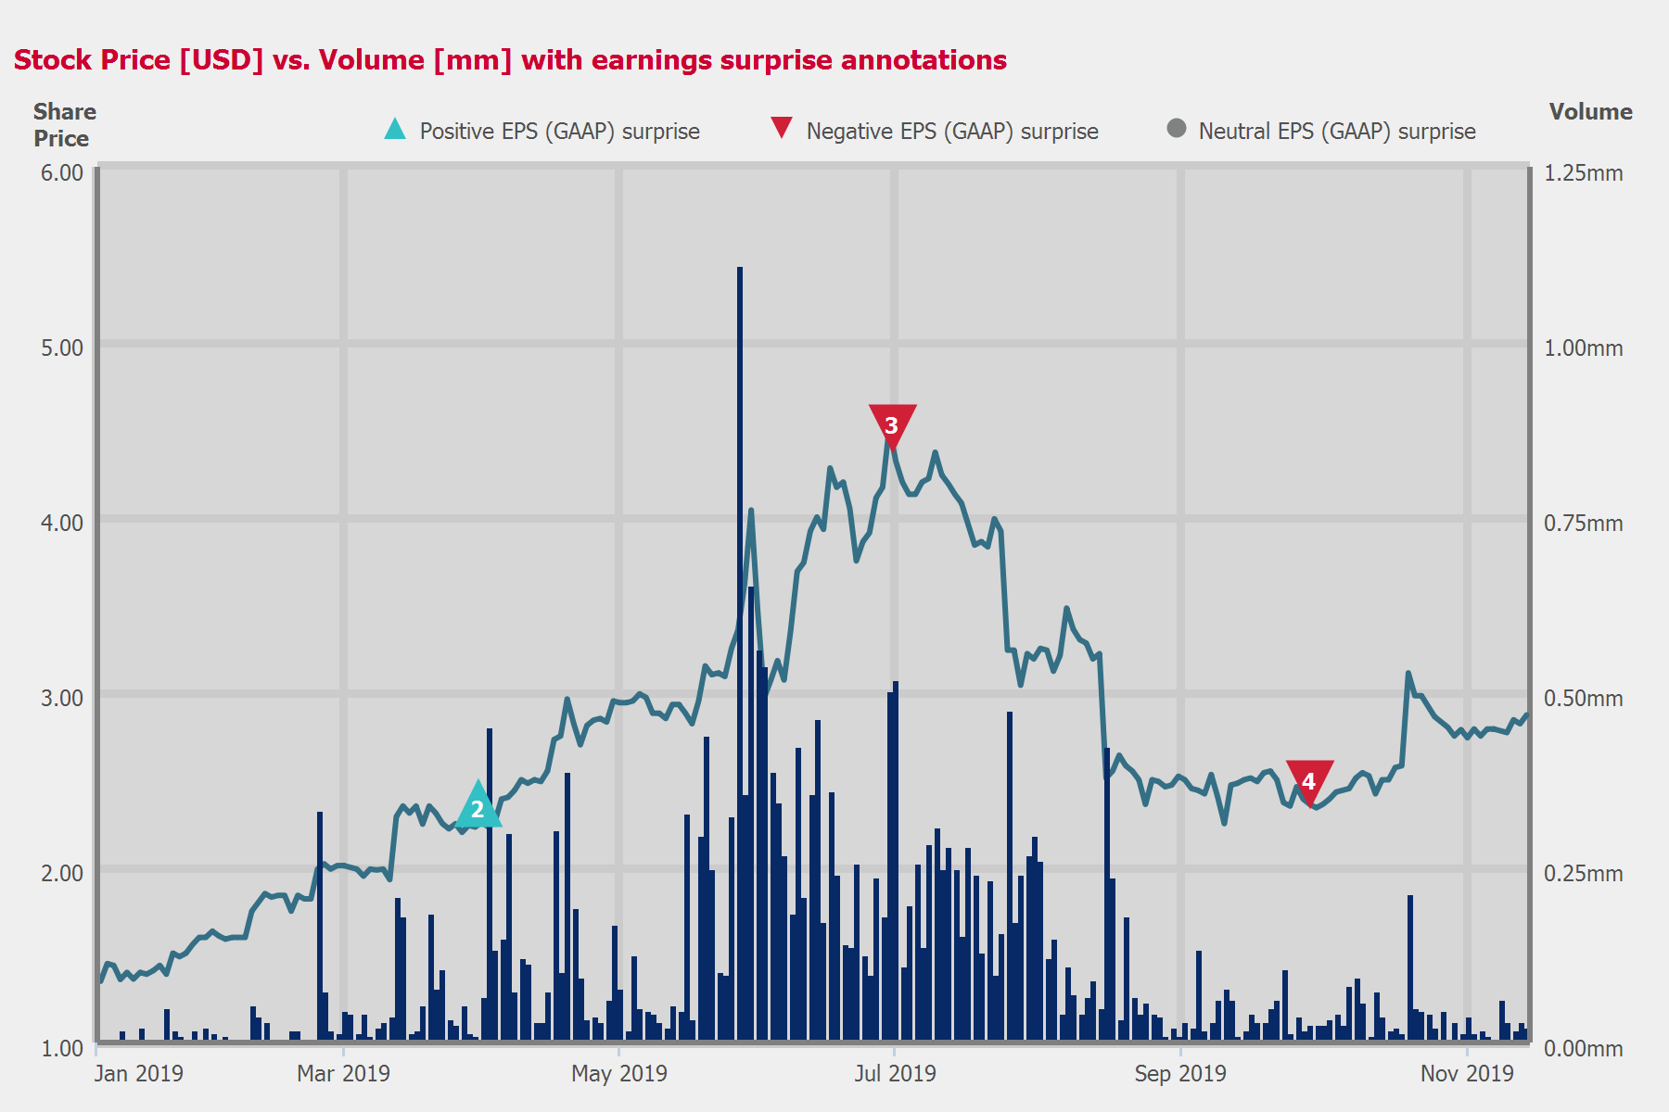
 |  |  |  | - EPS (GAAP) -
 | CONSENSUS |  | ACTUAL |  | SURPRISE
FQ4 2018 | 0.03 |  | (0.02) |  | NM
FQ1 2019 | 0.04 |  | 0.09 |  | 125.00 %
FQ2 2019 | 0.06 |  | 0.00 |  | (100.00 %)
FQ3 2019 | 0.05 |  | 0.03 |  | (40.00 %)

Table of Contents

Call Participants | ........................................................................................................................................................ | 3
Presentation | ........................................................................................................................................................ | 4
Question and Answer | ........................................................................................................................................................ | 7

Call Participants
EXECUTIVES
Daniel B. O’Brien
President, CEO, Principal Financial & Accounting Officer & Director
ANALYSTS
Unknown Analyst

Presentation
Operator
Good day, and welcome to the Flexible Solutions International Third Quarter 2019 Financial Results Conference Call. Today's conference is being recorded.
At this time, I'd like to turn the conference over to Dan O'Brien. Please go ahead, sir.
Daniel B. O’Brien
President, CEO, Principal Financial & Accounting Officer & Director
Thank you, Cassidy. Good morning. This is Dan O'Brien, CEO of Flexible Solutions.
The safe harbor provision. The Private Securities Litigation Reform Act of 1995 provides a safe harbor for forward-looking statements. Certain statements contained herein, which are not historical facts, are forward-looking statements with respect to events, the occurrence of which involve risks and uncertainties. These forward-looking statements may be impacted, either positively or negatively, by various factors. Information concerning the potential factors that could affect the company is detailed from time to time in the company's reports filed with the Securities and Exchange Commission.
Welcome to the call. Prior to speaking about our financials, I'd like to talk about our corporate condition and product lines, plus what we think might occur over the next several quarters.
Insurance compensation from the fire has been received in full, but the accounting and tax effects of the payments will continue to distort and complicate our financials until year-over-year comparisons that do not contain compensation or tax adjustments are available. The first quarter this will occur is Q1 2020.
Our NanoChem division. NCS represents more than half the revenue of FSI. This division makes thermal polyaspartic acid, called TPA for short, a biodegradable polymer with many valuable uses. NCS also manufactures SUN 27 and N Savr 30, which are used to reduce nitrogen fertilizer loss from soil.
TPA is used in agriculture to significantly increase crop yield. The method of action is by slowing crystal growth between fertilizer ions and other ions in the soil, resulting in the fertilizer remaining available longer for the plants to use. The attraction between the TPA and the fertilizer ions also retains the nutrients closer to the plant roots. Keeping fertilizer more easily available for crops to use results in better yield with the same level of fertilization. We do not recommend you reducing fertilizers, instead, the grower obtains more salable crop per acre farmed and a more profitable operation.
TPA in agriculture has a strong economic value for all links in the sales to end user chain. Even after our margin and the distributors' profits, the grower receives a good return on his investment in our products.
TPA is also a biodegradable way of treating oilfield water to prevent pipes from plugging with mineral scale. Our sales into this market are well established and normally grow steadily but slowly. A simple explanation of TPA's effect is that it prevents the scaling out of minerals that are part of the water fraction of oil as it exits the rock formation. Scale must be prevented to keep the oil recovery pipes from clogging.
SUN 27 and N Savr 30 are our nitrogen conservation products. Nitrogen is a critical fertilizer but subject to loss through bacterial breakdown, heat operation and soil runoff. Both our nitrogen products are becoming well respected, and sales continue to grow. They utilize much more environmentally friendly solvents than some of the competing products. SUN 27 is used to conserve nitrogen from attack by soil bacterial enzymes, while N Savr 30 is directed towards reducing nitrogen loss through leaching and evaporation. Each of our products are equal to or better than the competing products.
ENP, the October 2018 acquisition. ENP is focused on sales into the turf and golf markets, whereas our NCS sales are into real crop agriculture, 2 very distinct markets. We account for ENP as a subsidiary and expect it to generate consolidated revenue greater than $8 million for full year 2019. Historic data suggests that FSI should expect pretax profits greater than $1 million from this division with moderate and/or annual growth.
The strong quarters for ENP are 2 and 3 to match the U.S. spring and summer. Q3 rebounded well from the weather problems encountered in the spring, and ENP is positioned for growth in 2020.
The LLC investment announced in January. This investment generated quarterly cash flow and profits starting in Q1 2019, and as shown in the financials. The company we invested in is also ordering substantially more product from us each quarter of 2019 than it did in 2018. We expect this growth to continue for many quarters to come, which will further increase revenue and profitability. The LLC has started representing more of our product line internationally with small sales already booked. We expect this to grow over several seasons and benefit our NCS division while also increasing the profits from the LLC, which will show on our bottom line.
It's worth noting that the seasonality of the LLC sales is opposite to our North American sales, which will tend to smooth out our quarterly revenue in a positive manner. After a poor Q2, the LLC's purchases from us rebounded in Q3, as predicted, and look strong for fourth quarter and on into 2020.
WaterSavr. News regarding WaterSavr trials and sales will be released if and when they occur. As the rest of the company grows, WaterSavr will be less of a focus but will remain available for sale to existing and prospective customers.
Q4 2019 and the start of 2020. TPA, SUN 27, N Savr 30 for agricultural use have peak uptake in Q1 and Q2 with early buy volumes occurring in Q4. This is expected again at the end of '19 and in the first half of 2020. Our seasonality has been significantly reduced by the ENP acquisition and the LLC investment, indicating that Q4 should be strong. This, along with Q4 sales for U.S. early buy and winter crop programs, is expected to provide growth in Q4 relative to the year early.
It's important to remember that Q4 2018 was the first quarter that ENP was consolidated into FSI, and as a result, the growth rates to be expected in Q4 and through 2020 will be organic rather than acquisition levels.
Oil, gas and industrial sales of TPA increased compared to the previous year. Increased sales into this market vertical are expected to continue through to the end of the year and into 2020. And then full year '19 revenue will increase very strongly compared to '18, driven by historic operations, the ENP acquisition and the January LLC investments. We expect that profits and cash flow will also increase significantly, driven by the increases in the top line revenue.
Tariffs. Well, since September 30, '18, all our raw materials imported from China have included a 10% additional tariff, which rose to 25% in '19. U.S. customers have received price increases from us now that this inventory is being used. U.S. customers have received additional price increases when we began using inventory that was subject to the 25% tariff. International customers are not charged the tariffs because we are applying for the export rebates available to recover the tariffs. To hedge against the chance of even higher tariffs and to service the increased production in '19, we have increased inventory substantially. As a result, the accumulating tariff payments to the government are affecting our cost of goods, our cash flow and our profits negatively until the rebates are received. Rebates can take many months to arrive even once the inventory has been converted and exported. The total dollar amount due back to us has become significant and continues to increase. The rebates will increase the profitability and cash flow while decreasing the cost of goods for future quarters in which rebates are received.
Highlights of the financial results. Sales for the quarter increased 94% to $7.4 million compared with $3.82 million in Q3 '18. The result is a gain of $412,000 or $0.03 a share in the '19 period compared to a loss of $145,000 or $0.01 a share in '18.
Profit for the quarter and the year-to-date is good, but operating cash flow for the 9 months, which was detailed in our press release yesterday, plus our investment income is the number that shows how strong we have become by joining with ENP and investing in the Florida LLC, which is also a major customer.
Our working capital is adequate for all our purposes and is expected to increase during 2020 as revenue and retained earnings grow. We also have a line of credit with BMO at Harris Bank of Chicago. We're confident that we can execute our plans with our existing capital.
The ENP acquisition was funded with a loan from BMO Harris plus a convertible note to the seller and did not reduce our cash position. The LLC investment was made with cash on hand.
A text of this speech will be available on our website by Monday, November 18. E-mail or fax copies can be requested from Jason Bloom at jason@flexiblesolutions.com.
And thank you. The floor is open for questions. Cassidy, will you set that up, please?

Question and Answer
Operator
[Operator Instructions] First question comes from [ Raymond Hall of CFPI ].
Unknown Analyst
Any idea of the timing of the receipt of your first tariff rebate?
Daniel B. O’Brien
President, CEO, Principal Financial & Accounting Officer & Director
Unfortunately, no. Maybe a little more explanation would be appropriate on this. I mean you pay the tariffs when you bring the product in, and it goes into inventory tariff paid. When it's converted and then actually exported out of the United States to an international customer, and whereabouts 60% or -- 60% international, that is the time when you can begin to run the process of providing the government with the paperwork and asking for the rebates. So we have some rebate requests in already, but we also have tariff-paid inventory in inventory that until it's converted and shipped offshore, we can't even start the process. So this is a lengthy thing, and it's a huge drag on business. But I would like to say that standing up to international countries that don't play fair is the right thing to do.
So does that help you with the...?
Unknown Analyst
Yes. You had mentioned that the receivables now is a substantial number. Any color you can provide on that?
Daniel B. O’Brien
President, CEO, Principal Financial & Accounting Officer & Director
Because we don't know exactly what percent is going to go offshore and what percent stays onshore, I think I should probably stay out of the number area. But let's say that it's -- in my opinion, it's greater than $0.03 a share and less than $0.05.
Unknown Analyst
Okay. Perfect. And for 2020, are you still comfortable with the $0.15 payout?
Daniel B. O’Brien
President, CEO, Principal Financial & Accounting Officer & Director
Very much, still. The cash flow number shows that we're capable.
Operator
[Operator Instructions] Our next question comes from Taha [indiscernible].
Unknown Analyst
Just to kind of follow-up on that question, is there -- I know you've kind of quantified the impact of the tariffs the first 2 quarters. The first quarter was roughly $250,000 the pretax profits and then $200,000 in the second quarter. How much was it this quarter in terms of the tariff impact on pretax profit?
Daniel B. O’Brien
President, CEO, Principal Financial & Accounting Officer & Director
Well, I'm -- as I say, I'm not totally sure because we're not sure how much of our production is going to go offshore and be available for the tariff rebates and how much will stay onshore and be subject to higher pricing to our onshore customers. So without really knowing that split and not having asked for it, it would be probably best if I stay with what I told [ Raymond ], which is it's -- our total exposure here is greater than $0.03 a share and less than $0.05 for the year.
Unknown Analyst
Got it. For the year, yes. Got it. That's helpful. And just to -- I know you said that charters should be smooth in terms of the revenue kind of pattern in terms of the seasonality. Is there a reason why there was sort of a shortfall from the Q1 levels of close to $8.5 million of revenues? You guys did $7.4 million. Was it more of a seasonal thing this quarter relative to Q1? Or something else going on?
Daniel B. O’Brien
President, CEO, Principal Financial & Accounting Officer & Director
No. I -- let's be honest, smoothing is smoothing, but it's not mirror surface smoothing. My opinion is, going from $8.4 million to $7.4 million and then maybe wherever we are in the $7 million, high $7 millions, $8 millions for Q4, compared to our historic behavior, this is extreme smoothing. And of course, second quarter was very poor because of the wet spring that affected both ENP and NanoChem agriculture sales. So like all the big guys, Agrium and Simplot and so forth, we suffered at that point and we've recovered from it. I actually feel that -- and I know you're not supposed to argue with a shareholder, but I actually feel that we are smooth.
Unknown Analyst
Got it. No, no, no, that's helpful. So it was just kind of a normal course of business is what you're saying. Got it.
Daniel B. O’Brien
President, CEO, Principal Financial & Accounting Officer & Director
Absolutely. And to point out, we often have shipments that didn't happen this time. But in the past, we've had situations where, say, 3 container loads worth $150,000 each did not go out on the 30th and they did go out on the second of the following quarter, and that's $1 million variation right there.
Operator
And at this time, we have no further questions in queue.
Daniel B. O’Brien
President, CEO, Principal Financial & Accounting Officer & Director
Cassidy, this ends the conference call. Would you do the duty of cutting everybody off, please? Thank you.
OperatorAbsolutely. At this time, we have no questions in queue, and this conference has been concluded. You may now disconnect. Have a great rest of your day.
Copyright © 2019 by S&P Global Market Intelligence, a division of S&P Global Inc. All rights reserved.
These materials have been prepared solely for information purposes based upon information generally available to the public and from sources believed to be reliable. No content (including index data, ratings, credit-related analyses and data, research, model, software or other application or output therefrom) or any part thereof (Content) may be modified, reverse engineered, reproduced or distributed in any form by any means, or stored in a database or retrieval system, without the prior written permission of S&P Global Market Intelligence or its affiliates (collectively, S&P Global). The Content shall not be used for any unlawful or unauthorized purposes. S&P Global and any third-party providers, (collectively S&P Global Parties) do not guarantee the accuracy, completeness, timeliness or availability of the Content. S&P Global Parties are not responsible for any errors or omissions, regardless of the cause, for the results obtained from the use of the Content. THE CONTENT IS PROVIDED ON "AS IS" BASIS. S&P GLOBAL PARTIES DISCLAIM ANY AND ALL EXPRESS OR IMPLIED WARRANTIES, INCLUDING, BUT NOT LIMITED TO, ANY WARRANTIES OF MERCHANTABILITY OR FITNESS FOR A PARTICULAR PURPOSE OR USE, FREEDOM FROM BUGS, SOFTWARE ERRORS OR DEFECTS, THAT THE CONTENT'S FUNCTIONING WILL BE UNINTERRUPTED OR THAT THE CONTENT WILL OPERATE WITH ANY SOFTWARE OR HARDWARE CONFIGURATION. In no event shall S&P Global Parties be liable to any party for any direct, indirect, incidental, exemplary, compensatory, punitive, special or consequential damages, costs, expenses, legal fees, or losses (including, without limitation, lost income or lost profits and opportunity costs or losses caused by negligence) in connection with any use of the Content even if advised of the possibility of such damages. S&P Global Market Intelligence's opinions, quotes and credit-related and other analyses are statements of opinion as of the date they are expressed and not statements of fact or recommendations to purchase, hold, or sell any securities or to make any investment decisions, and do not address the suitability of any security. S&P Global Market Intelligence may provide index data. Direct investment in an index is not possible. Exposure to an asset class represented by an index is available through investable instruments based on that index. S&P Global Market Intelligence assumes no obligation to update the Content following publication in any form or format. The Content should not be relied on and is not a substitute for the skill, judgment and experience of the user, its management, employees, advisors and/or clients when making investment and other business decisions. S&P Global Market Intelligence does not act as a fiduciary or an investment advisor except where registered as such. S&P Global keeps certain activities of its divisions separate from each other in order to preserve the independence and objectivity of their respective activities. As a result, certain divisions of S&P Global may have information that is not available to other S&P Global divisions. S&P Global has established policies and procedures to maintain the confidentiality of certain nonpublic information received in connection with each analytical process.
S&P Global may receive compensation for its ratings and certain analyses, normally from issuers or underwriters of securities or from obligors. S&P Global reserves the right to disseminate its opinions and analyses. S&P Global's public ratings and analyses are made available on its Web sites, www.standardandpoors.com (free of charge), and www.ratingsdirect.com and www.globalcreditportal.com (subscription), and may be distributed through other means, including via S&P Global publications and third-party redistributors. Additional information about our ratings fees is available at www.standardandpoors.com/usratingsfees.
© 2019 S&P Global Market Intelligence.

